Supplemental Questions
Instructions
SJVLS would like to gather more detailed information about how proposed solutions can accommodate some of our specific services and processes. We will provide a detailed description of how these work on our current system. Vendors are asked to provide a written description of how their system can meet these requirements.
Deleting Items and Managing OCLC Holdings
Managing OCLC holdings is complicated in a consortium that shares bibliographic records. The challenge is to determine when a member adds their first copy of a title, or deletes their last copy, as opposed to looking for the first item or last item on a bibliographic record. SJVLS manages holdings by adding a bibliographic tag (959) to the MARC record with the member’s OCLC symbol to indicate holdings have been set for that member. Bi-weekly, SJVLS runs a SQL process that identifies bibliographic records where the member has at least one copy and the bibliographic record does not have a 959 tag with their OCLC symbol. The process adds the 959 tag to the bibliographic record and generates a list of OCLC numbers (tag 001), which are run through batch holdings updates via the OCLC client.
The process is reversed to delete OCLC holdings. To facilitate the process, staff mark items with a special status to indicate the item was withdrawn. SJVLS runs a SQL process that generates a report of the number of items deleted by location and deletes the items overnight through a batch delete process. The next day, a SQL process identifies bibliographic records where the member’s 959 tag is present in the bibliographic record, and the member does not have an item linked to the record. The 959 tags are deleted and a list of OCLC numbers is generated. The OCLC numbers are then used to delete the member’s holdings via the OCLC client. After the process, any bibliographic records with no items attached are then batch deleted overnight.
Please describe how your proposed solution supports managing OCLC holdings for individual jurisdictions within a shared catalog, either with the process described above, or through functionality in the ILS.

Hold Fulfillment
There are normally two processes through which a specific item fills a request:
- An eligible item is checked in and fills the request (Process 1) or
- A daily location level report targets items to pull from the shelves (Process 2)
SJVLS wants hold fulfillment to apply a logic that will generally fill requests in the first placed/first filled order (queue order) except when:
- With available items within a jurisdiction filling holds for pickup within that group of libraries first (jurisdiction copies get priority for jurisdiction holds), and
- Reducing transit times by filling with the “closet” copy.
Below are explanations of the desired logic for the two processes.
Process 1 – On checkin of an item with a pending request
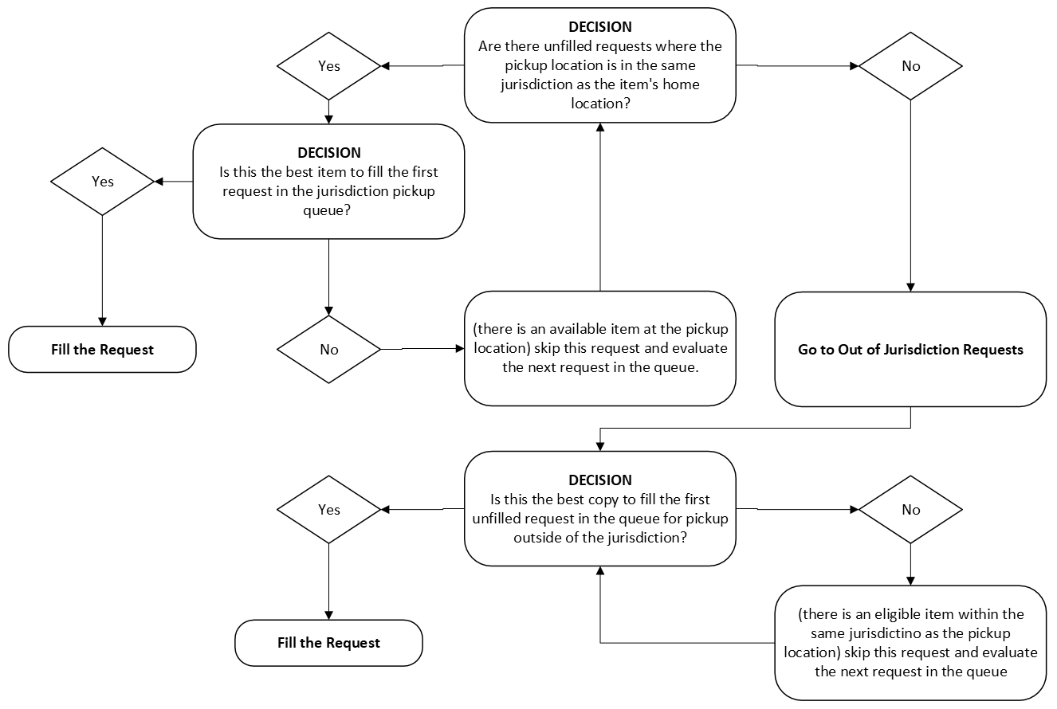

Process 2 – Report of items to pull off the shelf to fill requests
Requests are filled in queue order with the exception that a jurisdiction’s items have priority for filling their own requests before filling requests for pickup locations outside of the jurisdiction. In other words, a jurisdiction’s copies will not fill a request outside of the jurisdiction until all its own requests have been filled.

When there are multiple available items to fill a request, the software should choose the best item for the pickup location as follows:
- If there are X number of available items within my jurisdiction and within the first X number of requests there is one for pickup at my location, use my item to fill that request. An item location/pickup location match does not allow the request to jump over other unfilled requests in the queue if there are not enough available copies to fill all requests.
- If there are X number of available items within my jurisdiction and within the first X number of requests there are none for pickup at my location, fill the first request for pickup within the jurisdiction, provided that the pickup location does not have an available item.
- If there are no outstanding requests for pickup within my jurisdiction, fill the first request in the queue, unless the jurisdiction where the request will be picked up has an available copy, in which case, jump to the next request.
Please describe how your ILS manages hold fulfillment, how hold settings are configured, and whether you can support the process described above. Additionally, please explain what features your ILS offers to determine which available item is selected to fill a hold, and when multiple items meet the criteria. Are there other factors considered, such as last circulated, or the first library to run the holds report?

SJVLS’s Specialized Statistics and Reports
SJVLS tracks specialized statistics on ILS usage, in order to provide reports to our members or other governing agencies. Those statistics and reports are described in the Background of the RFP. Please describe how your system would support these reports.

E-Resources in Public Facing Applications
While SJVLS members share most of their physical collections, and SJVLS provides several e-resources systemwide including a shared CloudLibrary collection, our members do not share their OverDrive or Hoopla titles with patrons outside their jurisdiction. Every SJVLS member has their own OverDrive account, and 3 members have Hoopla subscriptions. As a result, SJVLS must have a way to ensure OverDrive titles held by one member do not appear in catalog search results of other members that do not own the title. We also need Hoopla titles to only appear in search results where the member has a subscription, and we need to be able to configure each member’s catalog profile to point to their Hoopla account.
In a catalog where members share bibliographic records, managing e-resource holdings through MARC records is challenging, and SJVLS does not want to manage manually loading MARC records for OverDrive or Hoopla content.
Please describe how your system manages e-book and e-audiobook records and holdings in an environment like SJVLS’s with multiple vendor accounts with different titles held by each.

Offline Circulation (for Vendor-hosted Solutions)
A vendor-hosted ILS solution will require connectivity between SJVLS’s network and the vendor. How would your solution handle a loss of connectivity? Please describe what offline circulation options are available for staff.

